Decimal Scaling

Definition
# Source: AI Source: Provided by: [Data Path: Persons Table -> ID Column: 1, Name_En Column: Motasem Essam] -> From: [Chatgpt (GPT‑5 Mini)] on [12/10/2025]
Decimal Scaling is a normalization technique that scales numerical values by moving the decimal point of the values. The number of decimal places moved depends on the maximum absolute value in the dataset.
The goal is to transform the values so that they fall within a smaller range, typically between −1 and 1.

Formula
# Source: AI Source: Provided by: [Data Path: Persons Table -> ID Column: 1, Name_En Column: Motasem Essam] -> From: [Chatgpt (GPT‑5 Mini)] on [12/10/2025]
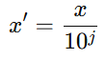
[
x' = \frac{x}{10^j}
]
Where:
- x = original value
- j = the smallest integer such that $max⁡(∣x^{'}∣)<1$
- x′ = normalized value

How It Works
# Source: AI Source: Provided by: [Data Path: Persons Table -> ID Column: 1, Name_En Column: Motasem Essam] -> From: [Chatgpt (GPT‑5 Mini)] on [12/10/2025]
- Find the maximum absolute value in the dataset.
- Determine the value of j so that dividing by (10^j) makes all values less than 1.
- Divide each value in the dataset by (10^j).

Example
# Source: AI Source: Provided by: [Data Path: Persons Table -> ID Column: 1, Name_En Column: Motasem Essam] -> From: [Chatgpt (GPT‑5 Mini)] on [12/10/2025]
Original dataset:
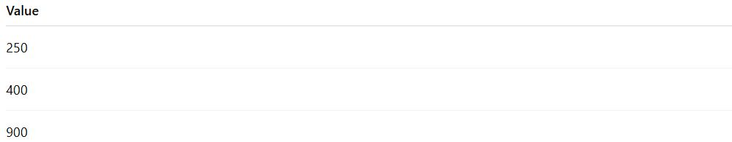
Value
250
400
900
Here the maximum value = 900.
To make the largest value less than 1, divide by 1000 ((10^3)).
Normalized dataset:
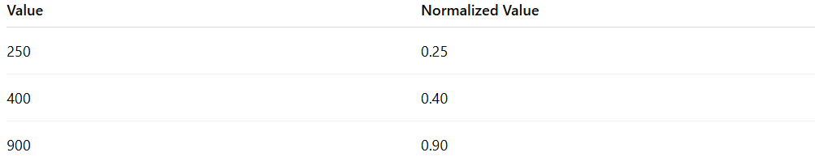
Value | Normalized Value
250 | 0.25
400 | 0.40
900 | 0.90

Advantages
# Source: AI Source: Provided by: [Data Path: Persons Table -> ID Column: 1, Name_En Column: Motasem Essam] -> From: [Chatgpt (GPT‑5 Mini)] on [12/10/2025]
- Simple and easy to apply
- Preserves the relative relationships between values
- Useful when the dataset values differ mainly by orders of magnitude

Disadvantages
# Source: AI Source: Provided by: [Data Path: Persons Table -> ID Column: 1, Name_En Column: Motasem Essam] -> From: [Chatgpt (GPT‑5 Mini)] on [12/10/2025]
- Less commonly used compared to Min–Max normalization and Z-score standardization
- May not perform well if the dataset contains large outliers

